4. Crypt-Arithmetic Problem
Aim
To write a Python program to solve a Crypt-Arithmetic problem.
Procedure
- Assign different digits to different letters.
- Ensure that the first letters are not zero.
- Generate possible digit combinations.
- Check whether the arithmetic equation is correct.
- Display the valid solution.
Program:
from itertools import permutations

letters = "SENDMORY"

for p in permutations(range(10), 8):
S, E, N, D, M, O, R, Y = p

if S == 0 or M == 0:
continue

SEND = 1000*S + 100*E + 10*N + D
MORE = 1000*M + 100*O + 10*R + E
MONEY = 10000*M + 1000*O + 100*N + 10*E + Y

if SEND + MORE == MONEY:
print("Solution:")
print("SEND =", SEND)
print("MORE =", MORE)
print("MONEY =", MONEY)
break
Output:
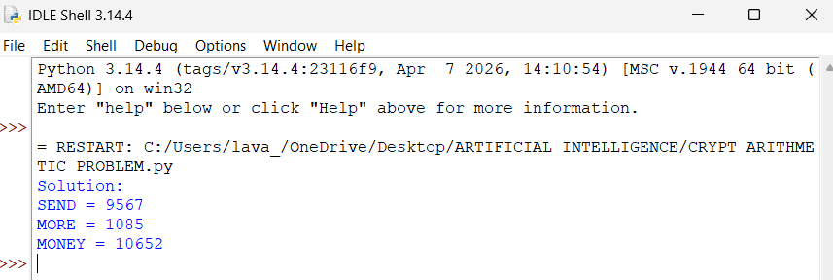
Result
Thus, the Crypt-Arithmetic problem was successfully solved using permutation and constraint checking.

